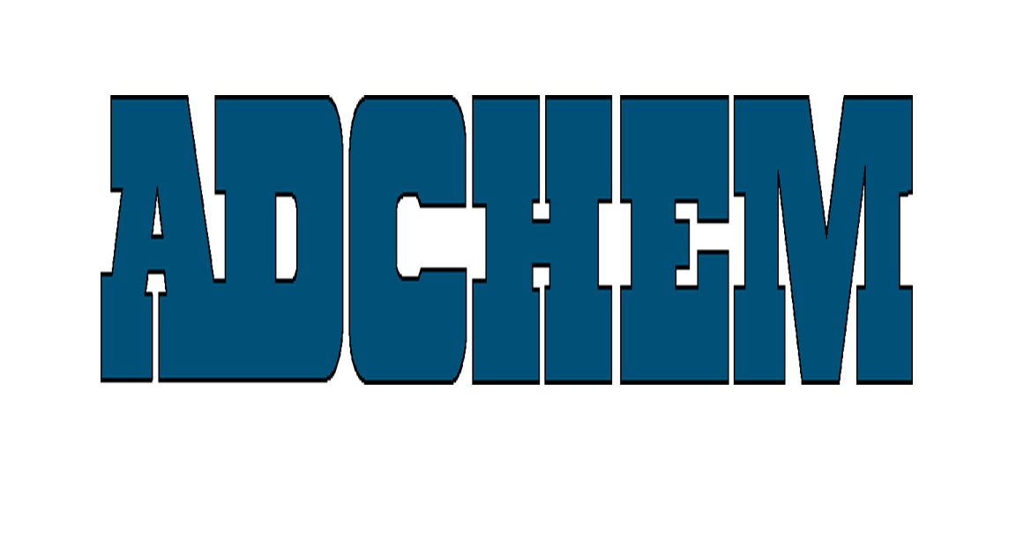
For Immediate Release:

Adchem Corporation Offers 7854 LSE High Performance Transfer Tape

Adchem Corporation, a leading manufacturer of innovative, pressure-sensitive adhesive tape systems, introduces its latest technology. Featuring a high performance adhesive transfer tape for bonding to TPO’s and other low surface energy materials such as powder-coated metals and polypropylene, 7854 also demonstrates an excellent bond to ether, ester, and low perm urethane foams as well as PVC foams. This high performance transfer tape is part of Adchem’s broad range of bonding solutions used in automotive, electronics and general industrial applications. Adchem manufactures acrylic and rubber adhesive systems in a variety of configurations for OEMs and fabricators worldwide.

Adchem’s 7854 transfer tape consists of 4-mils of a pressure-sensitive acrylic adhesive system with aggressive loop tack and peel characteristics combined with moderate shear properties. It is currently available on a 74# poly-coated release liner, engineered for easy release, and a 12-pt board liner, ideally suited for “kiss cutting” of laminated parts.

The leader in engineering transfer tapes for more than 40 years, Adchem provides more than 50 unique adhesive solutions for customers’ most demanding bonding needs. This broad range of products reduces the need for large inventories of narrower spectrum systems.

About Adchem Corporation

Adchem, an ISO 9001 certified and A2LA accredited company, manufactures an innovative line of pressure-sensitive adhesive tape systems, including double-coated papers, films, tissues, foams and fabrics; transfer tapes; one-side coated products and other custom-coated specialty products. Our 100% solids adhesives, solvent and water based acrylics and rubber adhesives are used in a variety of industries, including automotive, construction, electronics, graphic arts, medical, and general industrial tape applications.
For additional information and samples, please contact Adchem Corporation, 1852 Old Country Road, Riverhead, NY 11901 Phone: (631) 727-6000 Fax: (631) 727-6010 or our website at www.adchem.com.

